**DOCUMENTATION OF USER MANAGEMENT SYSTEM**

1. *First in the VIsual Studio Code Editor I had opened a split terminal which looked like this:*

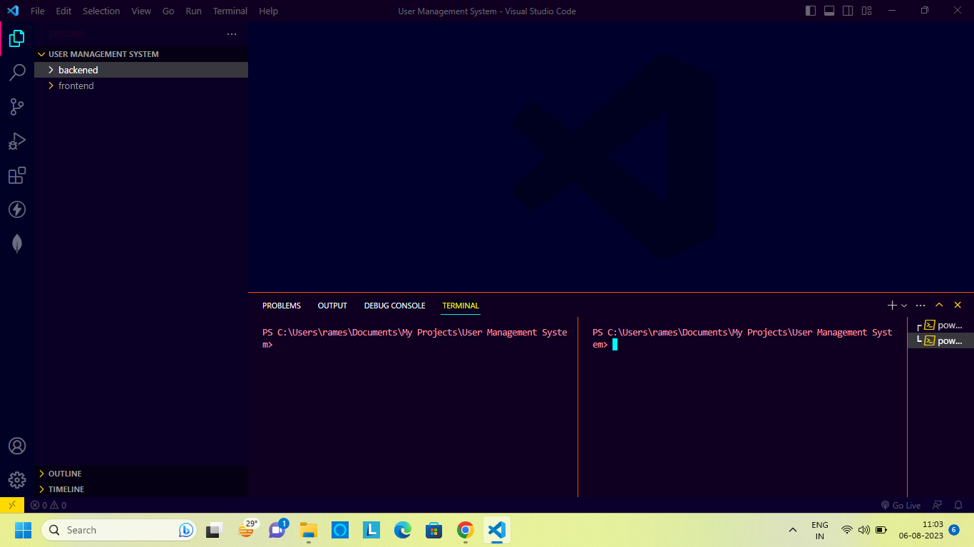

1. *Next I went to backened and frontend file directory by typing :***cd backened** *and* **cd frontend** *respectively, which looked like this:*

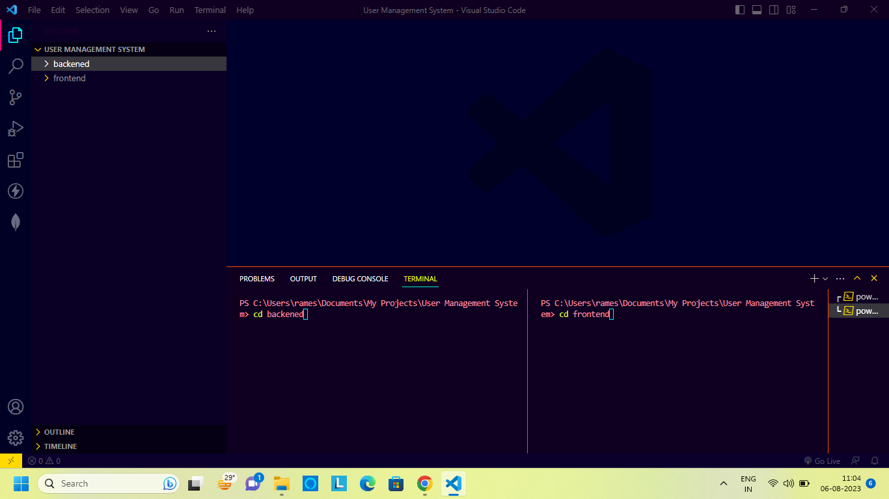

1. *After clicking enter on both sides the terminal looked like this:*

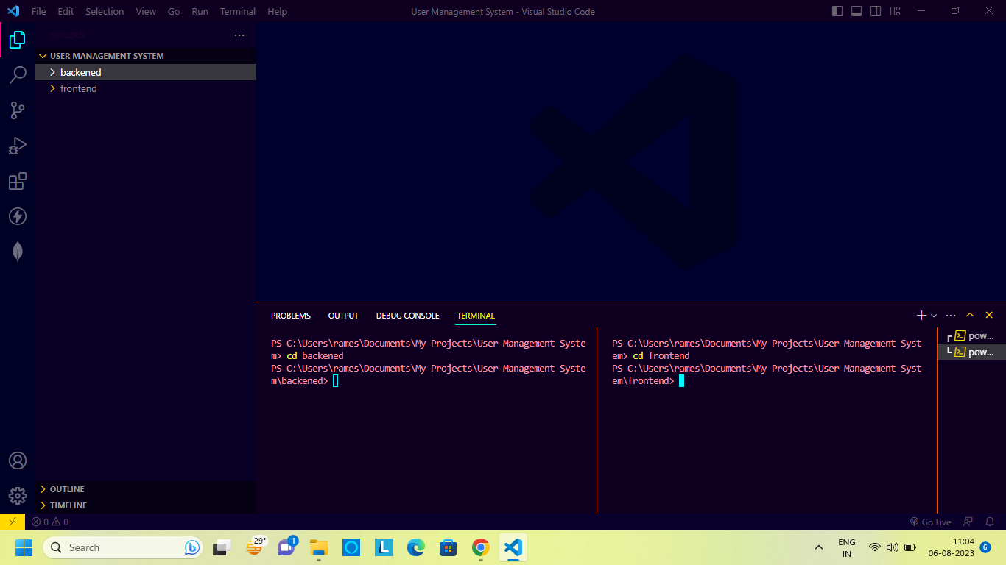

1. *Next I opened my backened file directory and frontend file directorry by the commands:* **npm run dev (for backened)** *and* **npm start(for backened)***which looked like this:*

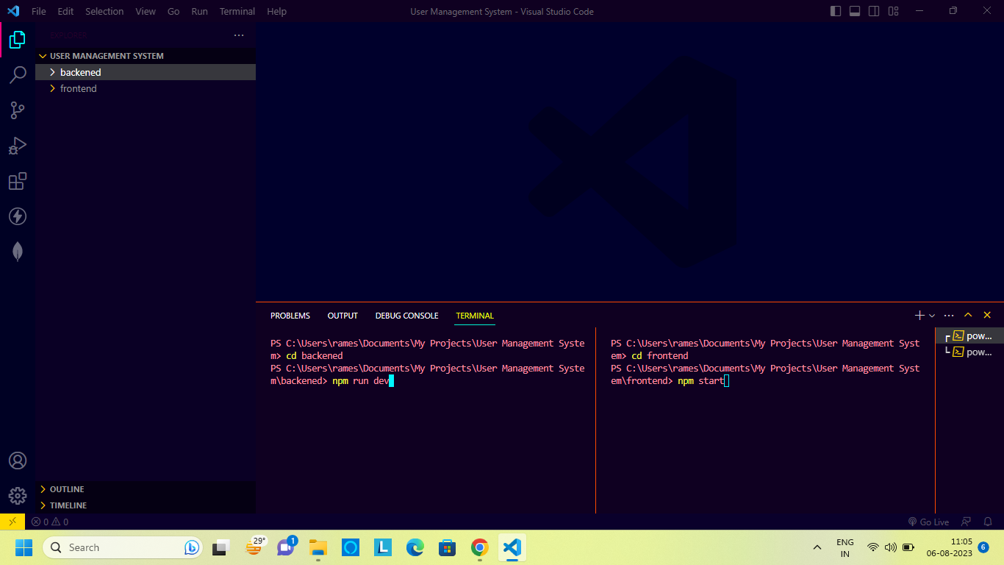

*5.The backened of the code looked like this:*

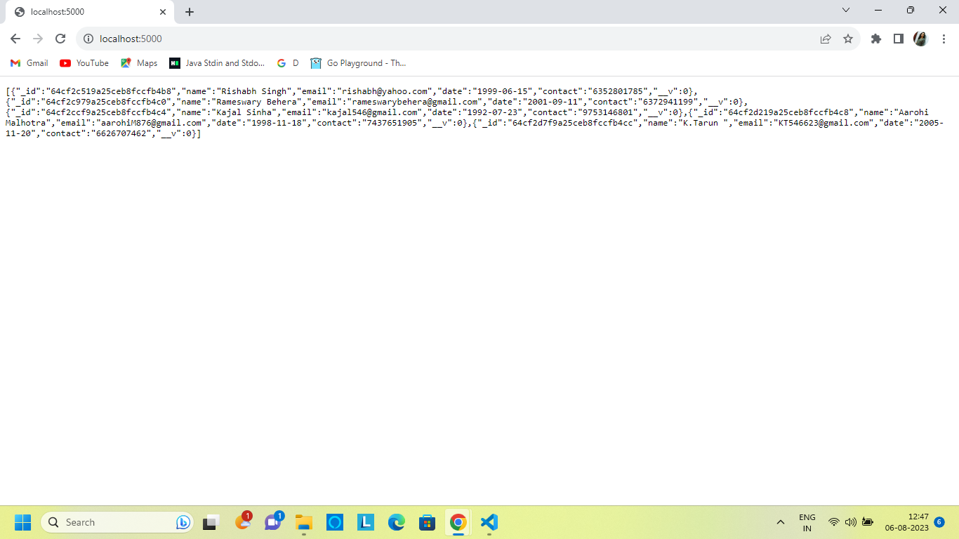

*6. The frontend part looks like this:*

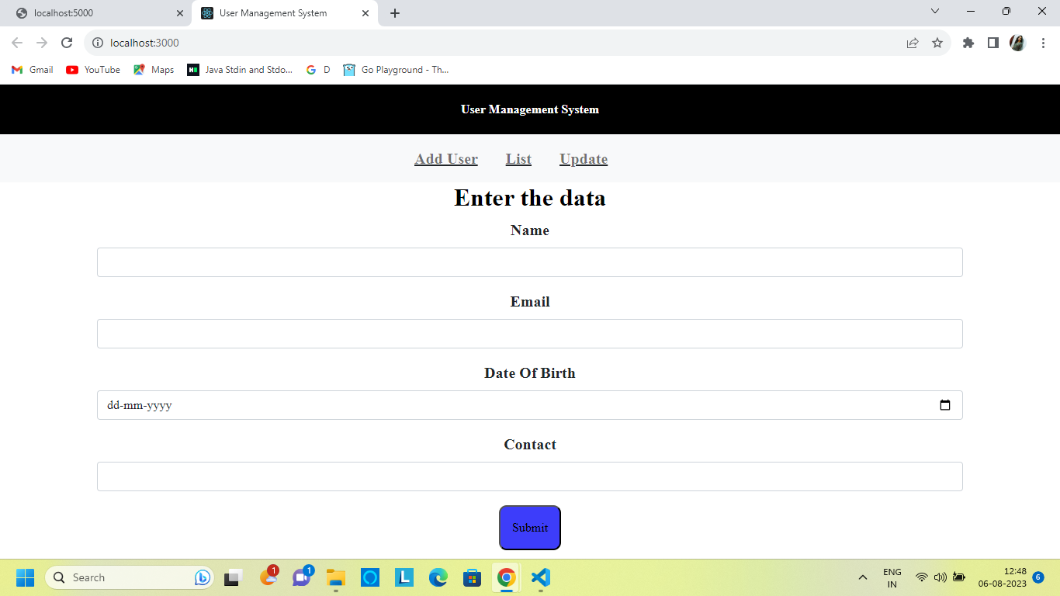

*7. Then, I had entered the data in the* **Add User** *page and hit the submit button:*

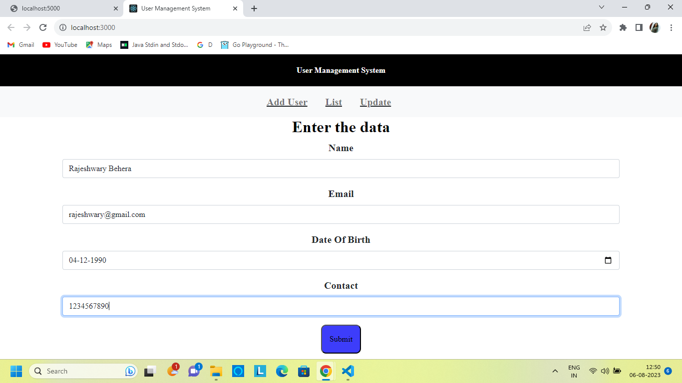

*8. The List page appears with the new data that was updated after I hit the submit button looks like this:*

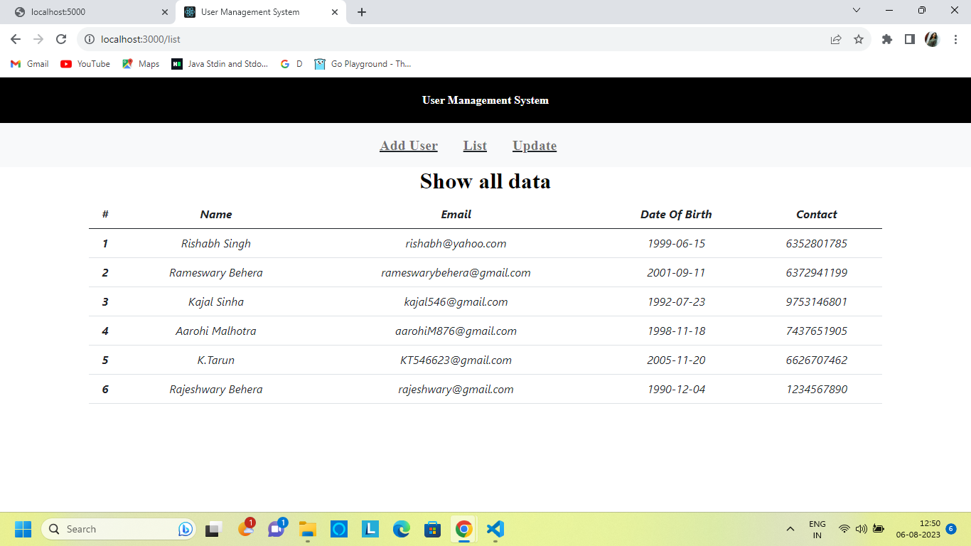

*9. Then I moved to the update page which looks like this :*

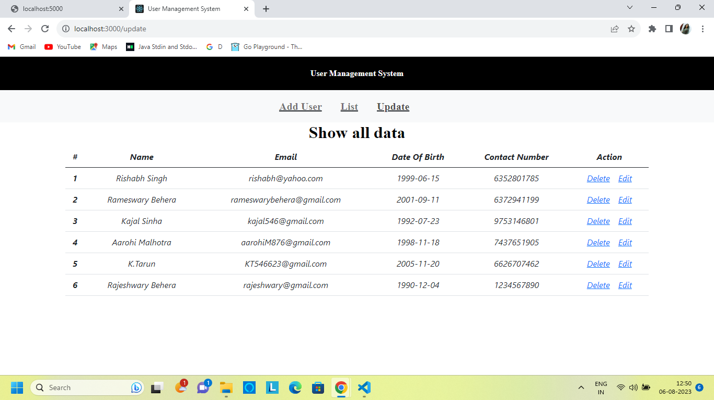

*10. When I clicked on the edit action, it navigated to the edit page which looks like this:*

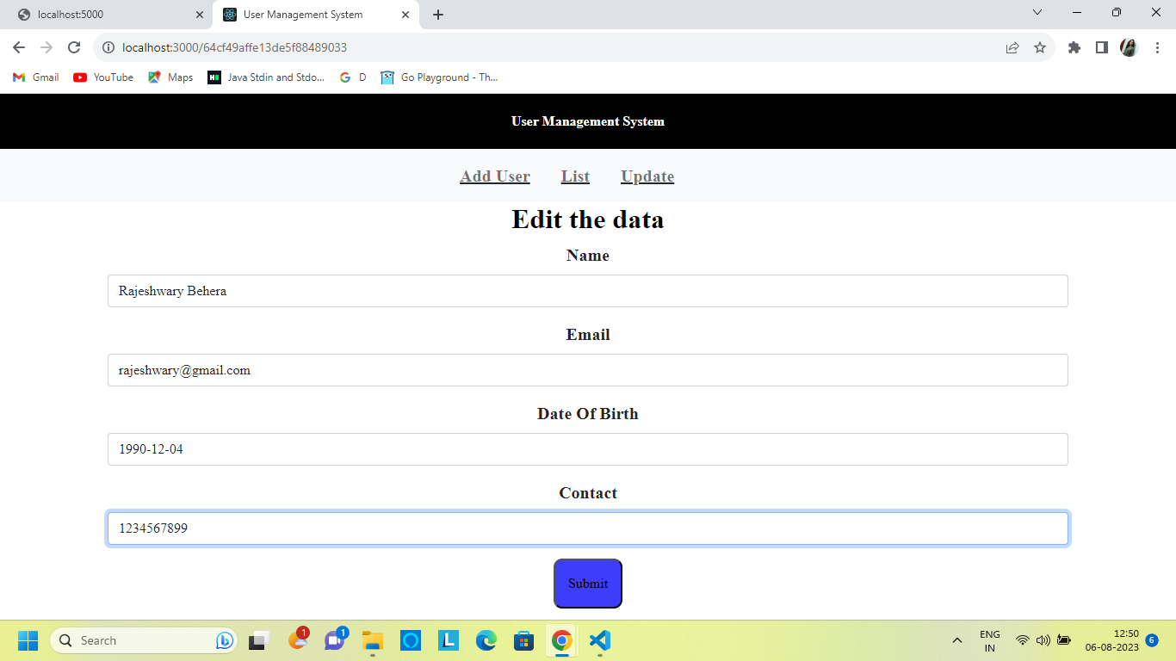

*11. The edit page by itself fills the details and allows us to change the required field. After changing the required field I had hit the submit button which navigated me to the List page with the updated data :*

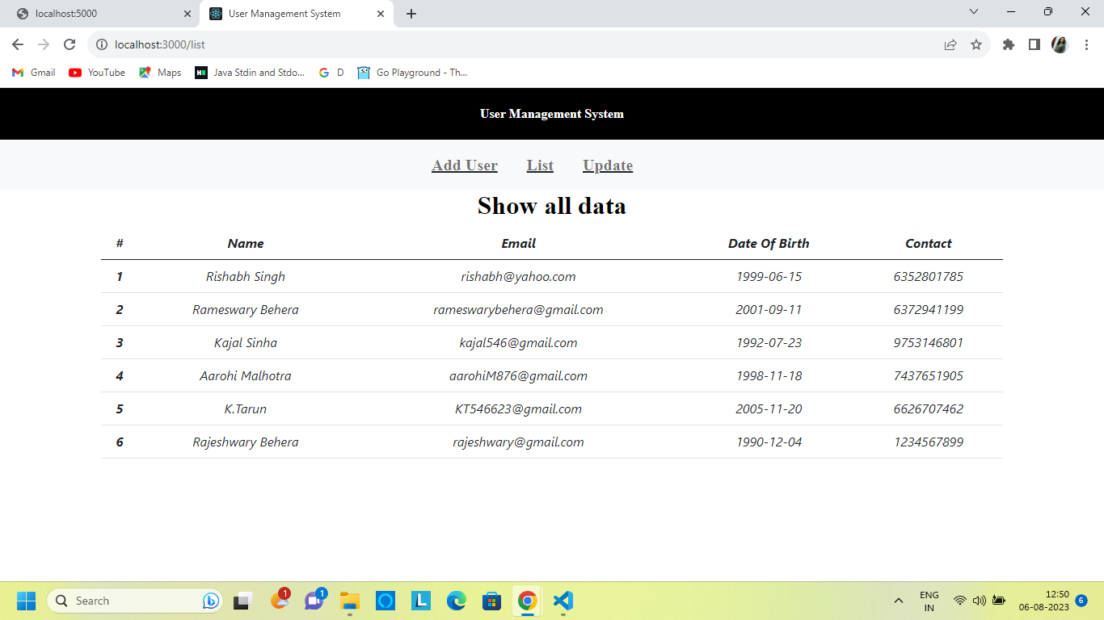

*12. I again navigated to the Update page and clicked on the delete action which showed me a pop up of the delete message and then the data was deleted. This looks like this:*

